Improving Business Systems
for Growth

If you want to grow your business you need to have a management structure in place so that you can get things done efficiently and good systems for people to follow to make operations go smoothly.

Management has as many definitions as there are managers; viewpoints, background, past experience, all influence any definition of management.

At the end of the day, management means getting things done through other people.
This article focuses on processes, i.e. the way the business develops new products, the way they fulfil orders, deal with customers and so on.

In effect, how to systemise the business. The idea of this article is to allow you to produce a report and facilitate a discussion of:

- How to identify the key systems the business needs to succeed;
- Improve Quality Management (QM);
- How to build systems and put procedures and scripts into place so that they work; and

Total quality management (TQM) is a requirement of growth

The four principles of quality management are:

- Measuring quality so you can affect it.

- Focus on the customer.

- Involve every employee.

- Think long term – act short term.

TQM where the whole organisation is involved and understands that customer satisfaction is everyone’s job. Quality means the extent to which products and services satisfy the requirements of internal and external customers. Management means the leadership, infrastructure and resources that support employee involvement in all business activities.

Without TQM a business will not grow as quickly as it could.

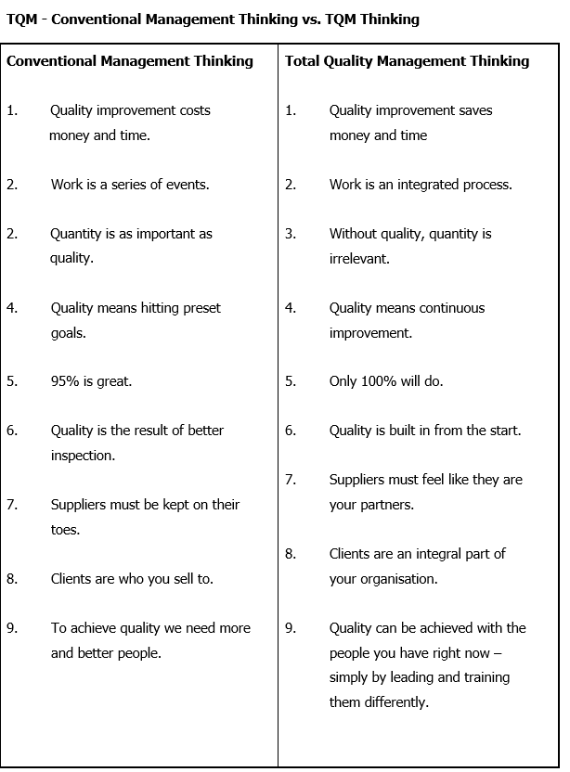
References worth reviewing about quality management

There are several classic books on TQM, and they are worth searching out on the internet as research.
The Deming Guide to Quality and Competitive Position.
Howard S Gitlow and Shelly Gitlow,
Englewood Cliffs, NJ: Prentice-Hall, Inc., 1987.

Juran’s Quality Control Handbook, 4th Edition.
J M Juran,
New York, NY: McGraw-Hill, 1988.

Quality is Free: The Art of Making Quality Free.
Philip B Crosby,
New York, NY: McGraw-Hill, 1979.

Quality Without Tears: The Art of Hassle Free Management.
Philip B Crosby,
New York, NY: McGraw-Hill, 1984.

Total Quality Control, 3rd Edition.
Armand V Feigenbaum,
New York, NY: McGraw-Hill, 1983.

Identify the key business systems

So if you want to grow you have to improve the quality management in your business and think about the key areas of the business that need systemising. In a successful business there will be several key systems:

- Generating leads
- Converting leads
- Measuring customer satisfaction
- Processing information
  - orders;
  - invoices;
  - payments;
  - management information.
- Production
  - orders;
  - doing the work.
- Measuring performance
- Employee development
(Note this is a guide – remember you will determine which systems are most important to your business.)

Ask yourself “what are the key frustrations on the business just now”

Make a note of them. Here are some questions to help. Take a day out to think about these questions and what systems should you put in place to improve things.

Do you agree with these Statements (yes or no)?

- I get bogged down in the detailed day to day work too often.

- I don’t get enough time in my personal life.

- Employees don’t really understand what we are all about.

- Employees are not as diligent as me.

- I’m working too hard.

- Too much of my time gets filled up with other people’s problems and administration.

- I am not sure what market position we are in.

- I am unsure about what is unique about my business.

- My employees do not know what is unique about our business.

- Our customers do not know what is unique about us.

- Potential customers do not know what is unique about us.

- The business does not have a marketing strategy.

- My bank manager is more in control of our finances than us.

- Our accounts are not as useful to me as I would like.

- I do not get enough financial information about my business as quickly as I would like.

- I never really know how we are doing long term.

- I don’t know how we stack up when compared to our competitors.

- We don’t do forward looking cash and profit projections regularly enough.

- We do not compare actual costs with forecast costs regularly enough.

- We do not set or use budgets in an efficient way.

- Reporting lines and relationships are not always clear.

- I am constantly having to supervise and guide my employees.

- Sometimes the quality of work is good but sometimes less than what I would expect.

- We are dependent on a few key personnel.

- We do not do enough staff training.

- We keep too much of how we do things in our heads and not in a written document.

- We do not have scripts and guidance notes on how to do things.

Comments:

Fundamental Challenges Priority List

List the challenges generally in the business. You will be looking to eliminate these as you go through the systems work.

The fundamental challenges in this business are:

Fundamental Challenges Worksheet

For each of the issues identified above, go through this step by step process eliminating the fundamental challenges you face in business. The steps of the process are outlined below.

- What’s the real problem we must face in this challenge?

- What is the main cause of the problem which presents this challenge?

  - Are we the major cause of the problem?
  - Is it predominantly the absence of a system?
  - Is someone else or something else the cause of the problem?

- Determine the real business problem.

- What results are we not getting in the business because of this problem?
- What is the annual financial effect of not dealing with the problem?
- Give examples of how we get distracted from our long-term aim by the impact of this problem.

- What is the ‘real’ problem?
  - What kind of system would eliminate the problem?
  - What result would have to be produced by a system designed to eliminate this problem?

The real problem in the business is the absence of a system that will [insert the benefits here] rather than [insert the cause of the problem].

- Design a system to eliminate the problem.
- Who designs the system?
- What are the main steps?
- What forms and documents will be needed to operate the system?
- What scripts will be needed?
- What elements of the management information package will be needed to measure any improvements?
- What employee training will have to take place?
- When is the system going to be up and running?

Systems Worksheet – list the important systems in your business

Now list down your existing systems in your business.

System | Name | Importance | Comments | Ranking

Ask yourself if any of these systems could be improved? Or whether they must be changed? Or if they are causing frustration or slowing you down?

For your key challenges and improvements to existing systems use the “Systems design sheet” below:

System Design Sheet
Title: |  | Date:
Result Statement
Describe the result this system must produce.

System Diagram
Identify the flow of work steps in the system and diagram them using boxes and arrows.

Responsibility

Use additional sheets as needed.

System Design Sheet (continued)

Title:
Deadline for Completion:
Time/Resources Needed:

Use additional sheets as needed.

System Design Sheet (continued)

System Description
Describe how this system will work.

Use additional sheets as needed.

Operating Manuals

Now that you have started systemising your business the next thing to do is write down “this is the way we do it here”.

These are descriptions of “how things are done” in the business. They are totally necessary if a business is going to standardise the way it does things and eliminate subjectivity in the delivery of a product or service.

They should be simple in a small business. In some clients they will be a normal part of the production process (e.g. ISO Standards) but most small businesses neglect operating manuals for all the other areas of their operations.

Operating manuals give the business owner a very effective way of standardising processes and give security to employees. It’s important to get the client started on this process, especially if the owners want to release themselves from the key frustrations they outlined in the strategy day.

The process involves:

- Gathering all existing information, documents etc about a process.
- Reviewing the systems flow chart (done in section 3).
- Putting all this together as operating manuals, so that employees can follow the scripts and processes easily.

Use the tools below to collect information and then outline the process (system) and how things are to be done.

Operating Manuals

Area:
Information/Documents Available:

Use additional sheets as needed.
Operating Manuals (continued)

Systems Flow Chart

 |  |  |  | Script Outline of Process |  | Reference
1
2
3
4
5
6
7
8
9
10

Operating Manuals (continued)

Systems Flow Chart

 |  |  |  | Script Outline of Process |  | Reference
1
2
3
4
5
6
7
8
9
10

Summary

The idea of this article is to allow you to produce a report and facilitate a discussion of:
- How to identify the key systems the business needs to succeed;
- Improve awareness of Total Quality Management (TQM);
- How to build systems and put procedures and scripts into place so that they work; and
Systemising a business doesn’t happen overnight – it can take months even in a micro business, but the benefits are enormous AND good systems allow for growth!

The next step is to continually monitor your systems, discussing with employees on improvements and to be dedicated to constant improvement in the business.

Clearly an online quality management system is the way forward for many businesses and ISO 9001 is generally considered the starting point.

ISO 9001 is one of the most recognised quality management systems globally. It was designed and continuously developed to be a key business development tool, providing a framework and set of principles that ensure a common-sense approach to the management of your business, to consistently satisfy customers and other stakeholders. In simple terms, it provides the basis for effective processes and effective people to deliver an effective product or service time after time.

For more information on quality management search out ISO 9001, online ISO and ISO Certification.

